Edward A. Morash
Associate Professor
Department of Supply Chain Management
Michigan State University
morash@bus.msu.edu

ACADEMIC DEGREES: B.A. Economics, 1968, Northeastern University
M.B.A. Business, 1971, University of Maryland
D.B.A. Doctorate in Business, 1979, University of Maryland

PROFESSIONAL EXPERIENCE 1985-present Associate professor of Transportation and Supply Chain
Management, Michigan State University
1980-1985 Assistant Professor of Marketing and Transportation,
Kent State University
1980 European Division, Assistant Professor of Marketing,
University of Maryland
1974-1979 Instructor of Business Administration, University of
Maryland, College Park
1960-1974 Vice President of Operations and Customer Service, other
Positions in sales and marketing management, Atlas Van
Lines

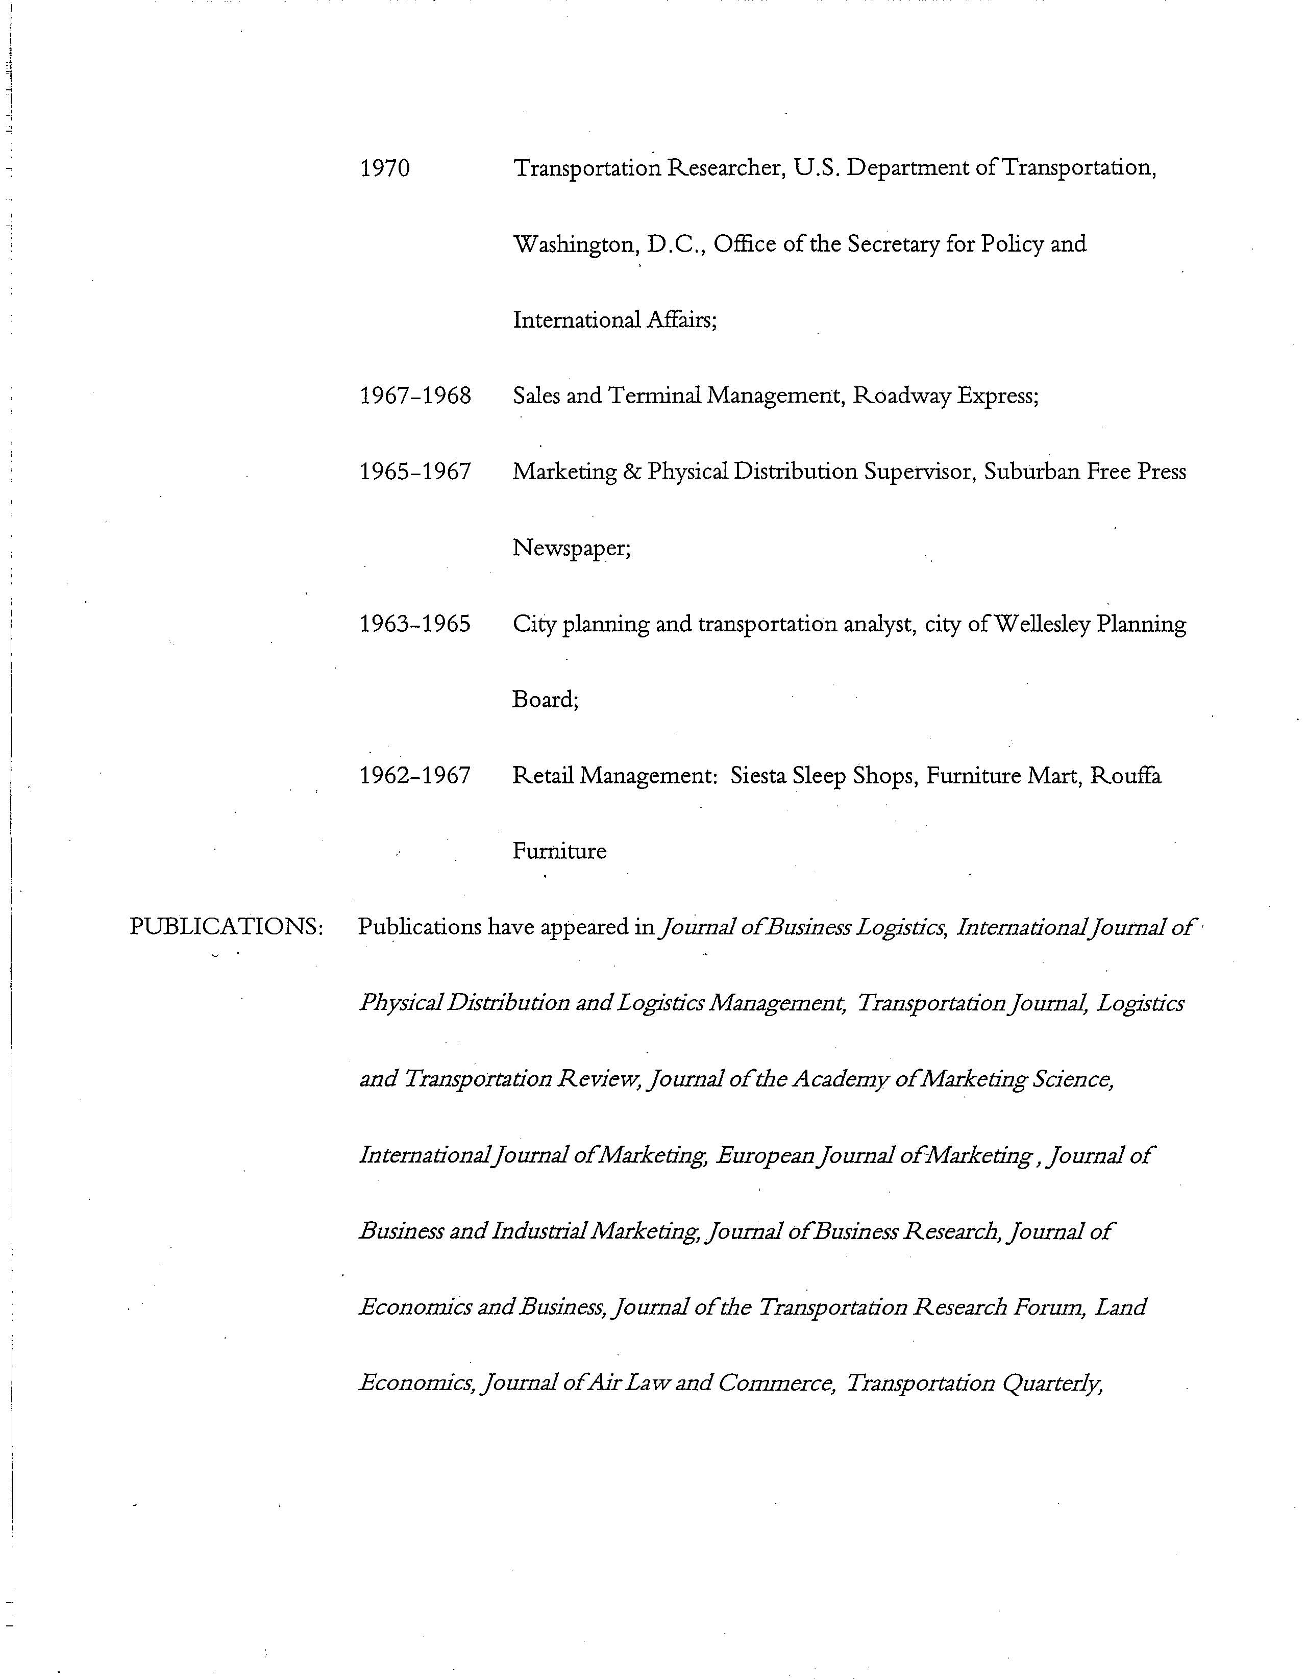
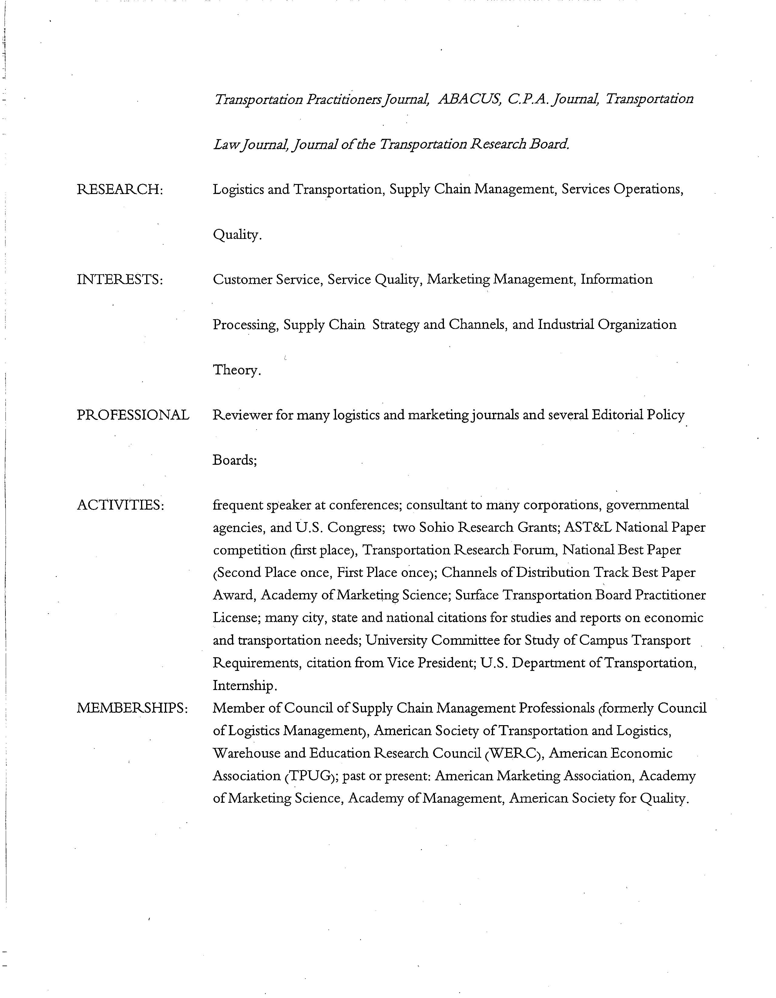
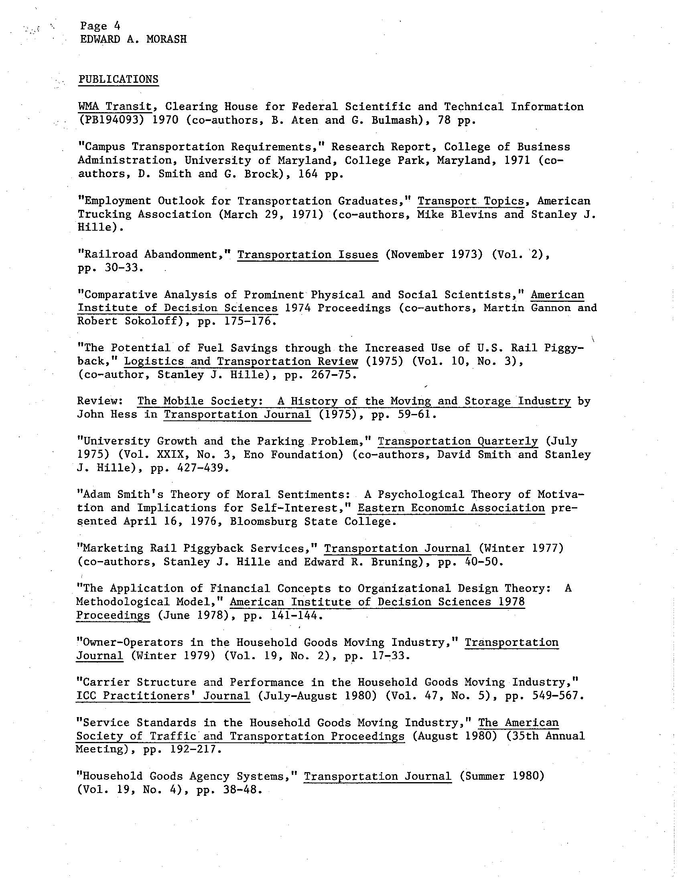

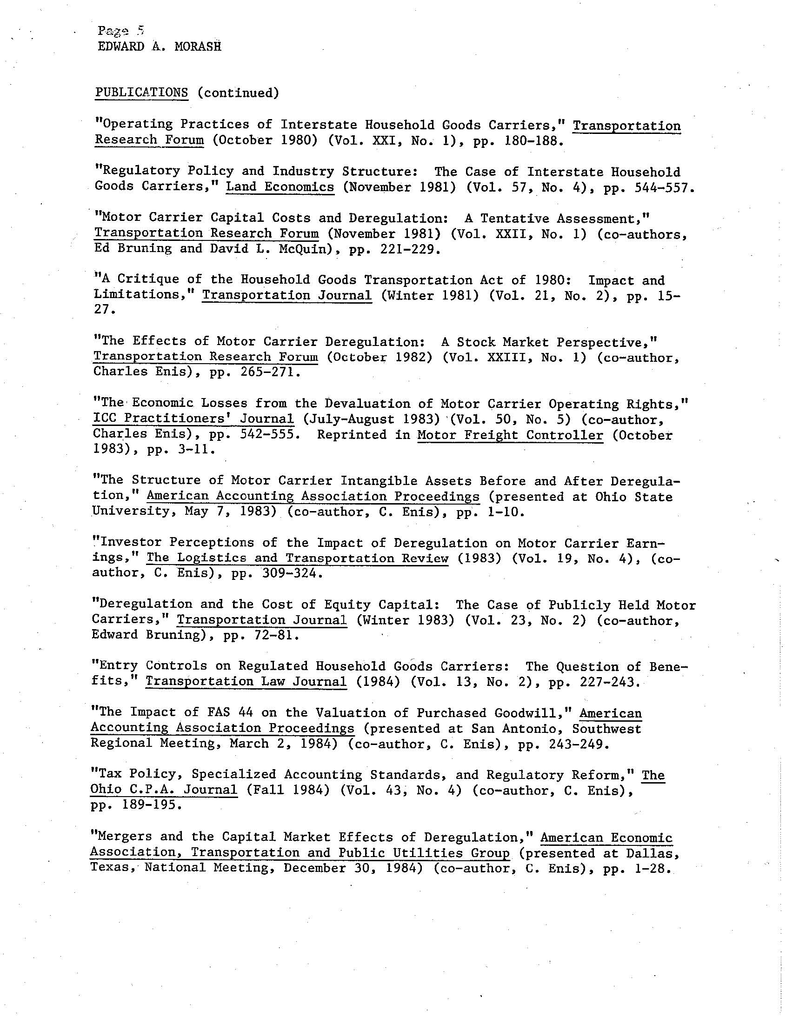
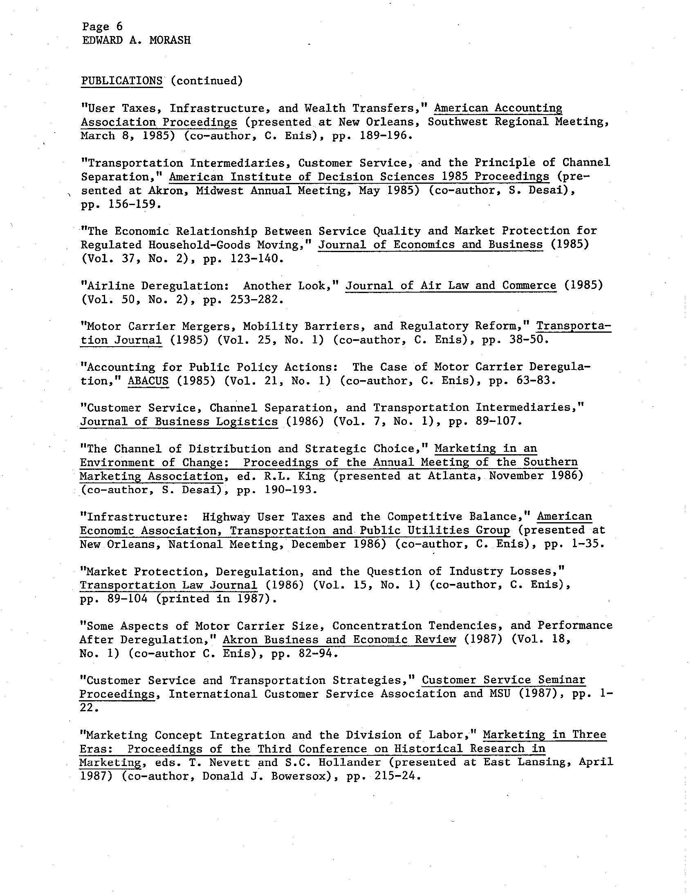
Page 7
EDWARD A. MORASH

PUBLICATIONS (continued)
“Highway User Taxes and Infrastructure Improvements: The Question of Benefits,” Journal of the Transportation Research Forum (1987) (Vol. 28, No.1) (co-author, C. Enis), pp. 334-341 (nominated for Best Paper National Award).
“Transportation Costs and Service Quality in a Deregulated Purchasing Environment,” Current Research in Purchasing and Materials Management: Proceedings of the 1987 National Purchasing and Materials Management Research Symposium, eds. J. R. Carter and G.L. Ragatz (October 1987), pp. 46-59.
“Using Transportation Intermediaries for Industrial Purchasing Decisions, “The Journal of Business and Industrial Marketing (1987) (Vol. 2, No. 4), pp. 15-27.
“Boundary Spanning in Channels of Distribution,” Developments in Marketing Science: Proceedings of the 1988 Academy of Marketing Science Annual Conference Vol. XI (April 28, 1988) (co-authors, D.J. Bowersox and P.J. Daugherty) (Received Best Paper Award in Track.
“The Integration of Marketing Flows in Channels of Distribution, “European Journal of Marketing (1989) (Vol.23, No.2) (co-author, Donald J. Bowersox), pp.58-67. (Paper reprinted in book: “Distribution Channels Management, ed. David Shipley).
“Towards a Contingency Theory of Channel Control,” in Advances in Marketing, eds. P.J. Gordon and Bert J. Kellerman (Spring 1989) (Southwestern Marketing Association) (co-author, C. Enis), pp.1-10. (This paper received three nominations for a Best Paper Award and is the lead article in the collection).
“An Investigation of the Effect of New Information Disclosures on Anchoring and Adjusting Behavior,” Proceedings of the 1989 Annual Meeting of the American Accounting Association (co-author, Lynn Pringle), pp. 27-34.
“Deregulation of the Motor Freight Industries: The Question of Benefits,” in Marketing: A Return to the Broader Dimensions, ed. S. Shapiro and A.H. Walle (1988) American Marketing Association Winter Educators’ Proceedings), (co-author, C. Enis) pp. 19-23.
“The Impact of Highway Excise Taxes on Rail-Motor Competition,” Proceedings of the Eightieth Annual Conference of the National Tax Association—Tax Institute of America (December, 1988) (co-author, C. Enis), pp 204- 211.

Page 8
EDWARD A. MORASH

PUBLICATIONS (continued)
“A Synopsis of a Methodology to Determine the Net Cost-Benefit of Highway Improvements and Increased Taxation,” Proceedings of the Annual Meeting of the Transportation Research Forum (October, 1988) (co-author, C. Enis) pp. 38-41.
“Assessing the Impact of Marketing Mix Interactive Effects: Some Empirical and Conceptual Underpinnings,” 1989 American Marketing Association Summer Educators’ Proceedings (co-author, J.D. Ozment), pp. 51-55.
“On the Use of Transportation Strategies to Promote Demand,” Logistics and Transportation Review (1990) (Vol. 26, No. 1), pp. 53-76
“Rail Selection, Service Quality, and Innovation, “ Journal of the Transportation Research Forum, (1992) (Vol. 32, No. 1) (co-author, Roger Calantone). pp. 205-215.
“Managing Service Quality,” Proceedings of the 1992 Winter AMA Educators Conference. (co-author, J. D. Ozment), pp. 120-121.
“An Examination of Relationships Between Transportation Costs and Service Quality in the U.S. Domestic Passenger Airline Industry,” Proceedings of the 1991 33rd Annual Meeting of the Transportation Research Forum. (co-authors, J. Ozment and K. Clow), pp. 81-94
“Intermodal Innovation, Service Quality, and Modal Choice.” Proceedings of the 1991 Annual Meeting of the Transportation Research Forum. (co-author, R.Calantone), pp. 471-480. Received National Best Paper Award.
“Infrastructure Taxes, Investment Policy, and Intermodal Competition for the Transportation Industries,” Journal of Economics and Business (February 1993)(Vol. 45, No. 1) (co-author, C. Enis), pp. 69-90.
“Airline Costs and Service Quality in a Deregulated Environment, “ Journal of the Transportation Research Forum (1992) (Vol. 32, No. 2), (co-author, J. D. Ozment), pp. 300-312.
“State Regulation of Motor Carriers in a Deregulated Transportation Environment,” Transportation Journal (Spring 1991), (Vol. 30, No. 3) (co-author, G.D. Wagenheim), pp. 39-56.
“The Impact of Federal Deregulation on State Regulatory Attempts,” American Economic Association, Transportation and Public Utilies Group 1990 Annual Proceedings (Spring 1991), (co-authors, G.D. Wagenheim and J.C. Taylor), pp. 7-8

Page 9
EDWARD A. MORASH

PUBLICATIONS (continued)
“Interactive Effects of Variables in the Marketing Mix: Tactical and Strategic Implications,” in Bill Pride and O.C. Ferrell,eds, Marketing Concepts and Strategies, 7th edition, Lecture Enrichment Series, Chapter 19, (Boston: Houghton Mifflin), (co-author, J.D. Ozment), pp. 140-147.
“Managerial Incentives and Motivational Horizons in the Motor Carrier Industry,” Proceedings of the National 1989 Meeting of the Decision Sciences Institute, ed. Ashok Soni (November 1989) (co-author, C. Enis), pp. 117-119.
“Transportation Costs and Service Quality: An Analysis of Competing Hypotheses,” Academy of Marketing Science Proceedings (May 29, 1993), pp. 595.
“Productivity and Quality in the Transportation and Logistics Industries,” TIMS/ORSA Bulletin No. 35, 35th Joint National Meeting of TIMS/ORSA, (May 1993), pp. 104.
“Objective versus Subjective Measures of Customer Service Satisfaction and Quality,”ORSA/TIMS Bulletin No. 36, 36th Joint National Meeting of ORSA/TIMS, (November 1993), pp.28.
“Some Dimensions of Transportation Costs, Service Quality, and Customer Services,” Journal of Transportation Management (December 1993), pp. 10-23.
“Global Logistics Research Team: Global Logistics Best Practice: An Intermediate Research Perspective,” Council of Logistics Management Annual Conference Proceedings (1994) (numerous team co-researchers and Conference co-presenters, pp. 27-42).
“Towards Management of Transportation Service Quality,” Logistice and Transportation Review (June 1994) (Vol. 30, No. 2), (co-author J.D. Ozment), pp. 115-140. This was the lead article in the Journal issue.
“The Augmented Service Offering for Perceived and Actual Service Quality,” Journal of the Academy of Marketing Science (1994) (Vol. 22, No. 4), (co-author, J.D. Ozment), pp. 352-363.
“Channel Integration and Strategic Alliances for Competitive Advantage in the Pacific Basin,” in Marketing Theory and Practice: Toward the 21st Century, 1995 AMA-KMA Joint Conference Proceedings, eds. J. Lim and S.T. Cavusgil (co-authors H.D. Yoon, M.B. Cooper and S. Clinton), pp. 240-253.
“World Class Logistics Practices: A Pacific Region Perspective,” Paper presented at the 1995 Annual Meeting of the Council of Logistics Management (Oct. 8-11 1995) (co-authors M.B. Cooper and H.D. Yoon), pp. 1-22.

Page 10
EDWARD A. MORASH

PUBLICATIONS (continued)
“Channel and Marketing Integration,” Annual Conference of Industrial Economic Institute (1995) (co-authors, H.D. Yoon, M.B. Cooper and S.R. Clinton), pp. 20-35.
“Global Logistics Research Team at Michigan State University, World Class Logistics: The Challenge of Managing Continuous Change (1995), Council of Logistics Management, Oak Brook, IL.
“Channel and Logistical Integration: A Comparison of North American and Asian-Pacific Practices,” Proceedings of the 1995 Facing East/Facing West Conference (May 1995) (co-author, S. Clinton), pp. 20
“Supply Chain Structure for Total Cost Reduction: Some International Comparisons,” Proceedings of the 37th Annual Meeting of the Transportation Research Forum (Oct. 1995) (co-author, S. Clinton), pp. 12.
“Channel Management and Relationship Marketing: Some Global Comparisons,” Proceedings of the 1995 AMA Summer Educators’ Conference: Enhancing Knowledge Development in Marketing, eds. B. Stern, G. Zinkham, P. Gordon, B. Kellerman (co-author, S. Clinton), p. 565.
Strategic Logistics Capabilities for Competitive Advantage and Firm Success,” Journal of Business Logistics (1996) (Vol. 17, No. 1) (co-authors, C. Droge and S. Vickery), pp. 1-22. This was the lead article in the Journal.
“Comparing Objective Service Failures and Subjective Complaints: An Investigation of Domino and Halo Effects,” Journal of Business Research (1996) (Vo. 36, No. 2) (co-author, D. Halstead), pp. 107-115
“Scheduling Management of Transportation Service Response Capacity to Improve Quality,” Logistics and Transportation Review (Dec. 1995) (Vol. 31, No. 4) (co-author, J.D. Ozment), pp. 353-376.
“Relationship Marketing: International Comparisons of Channel and Logistical Integration Interfaces,” Proceedings of the 1996 Academy of Marketing Science Annual Conference (1996) (co-author, S. Clinton), pp. 3.
“Accounting for Productivity and Quality in the Airline and Transportation Industries,” Transportation and Public Utilities Group: American Economics Association Annual Meeting (Fall 1996)(co-author, C. Enis), pp. 1-20. This paper was the lead paper in the AEA session.

Page 11
EDWARD A. MORASH

PUBLICATIONS (continued)
“Global Comparisons of Channel Integration Strategies and Strategic Alliances,” Advances in International Marketing, eds. S.T. Cavusgil and C.R. Taylor (1996) (Vol. 7:JAI Press, Greenwich CT) (co-authors, H.D. Yoon, M.B. Cooper and S.R. Clinton), pp. 3-20. This paper was the lead article in the book.
“Productivity and Quality Relationships,” 38th Annual National Meeting of the Transportation Research Forum Proceedings (1996) (Vol. 1), pp. 33-37.
“Boundary Spanning Interfaces Between Logistics, Production, Marketing, and New Product Development,” International Journal of Physical Distribution and Logistics Management (1996) (Vol. 26, No. 8) (co-authors, C. Droge and S. Vickery), pp. 43-62.
“The Strategic Use of Transportation Time and Reliability for Competitive Advantage, Transportation Journal (Winter 1996) (Vol. 36, No. 2), (co-author, J. Ozment), pp. 35-46.
“The Economic Efficiency Impacts of Global Supply Chain Integration,” Transportation Research Board Preprint Proceedings: 77th Annual Meeting (1998) (Washington, D.C.), pp. 60.
“An Evaluation of Transportation Performance Measures,” Federal Highway Administration Workshop Productivity and Performance Indicators (1998) (FHWA, U.S. Department of Transportation, Washington, D.C.), pp. 1-31.
“Quality and Performance in the U.S. Airline Industry: A Preliminary Investigation,” Transportation Research Board Preprint Proceedings: 77th Annual Meeting (1998) (Washington, D.C.), pp. 1-22.
“Boundary Spanning Interfaces Between Logistics, Production, Marketing, and New Product Development,” International Journal of Physical Distribution and Logistics Management (1997) (Vol. 27, No. 5/6) (re-print with co-authors, C. Droge and S. Vickery), pp. 350-369.
“The Role of Transportation Capabilities in International Supply Chain Management,” Transportation Journal (1997) (Vol. 36, No. 3) (co-author, S. Clinton), pp. 5-17.
“The Economic Impact of Transportation Public Policy on Supply Chain Capabilities and Performance,” ENO Transportation Foundation Forum: Transportation Investment and New Insights from Economic Analysis (February 1999) (Washington D.C.), pp. 1-28.

Page 12
EDWARD A. MORASH

PUBLICATIONS (continued)
“Transportation Public Policy and Global Logistics Performance,” OECD Symposium on Public Policy Issues in Global Freight Logistics (December 1998) (Washington, D.C.), pp. 1-14.
“Supply Chain Integration: Customer Value Through Collaborative Closeness Versus Operational Excellence,” Journal of Marketing Theory and Practice: Special Issue on Supply Chain Management (1999) (co-author, S. Clinton), pp. 1-16.
“Assessment of the Relationship Between Productivity and Performance Quality in the U.S. Domestic Airline Industry,” Transportation Research Record (peer-reviewed Journal of the Transportation Research Board, National Academy of Sciences, Washington, D.C.) (1998) (No. 1622), (co-author, John Ozment), pp. 22-30. This is the lead article in the Journal issue.
“The Economic Impact of Transportation Public Policy on Supply Chain Capabilities and Performance,” 1999 Proceedings of the 41st Annual National Meeting of the Transportation Research Forum (October 1999), pp. 391-417.
“Transportation Planning, Policy, and Performance,” Journal of the Transportation Research Forum (2000) (Vol. 39, No.1), pp. 22.
“Transportation and Logistics Performance Measurement,” 2000 Proceedings of the Transportation Research Board Annual Meeting (January 2000), pp. 25-34.
“Demand-Based Transportation Planning,” Transportation Quarterly (Winter 2000) (Vol. 54, No. 1), pp. 11-33. This is the lead research article in the Journal issue.
“Productivity from Transportation Infrastructure: Improvements in Capacity, Condition, and Congestion,” Proceedings of the 2001 Annual Meeting of the Transportation Research Board (January 2001) (Washington, D.C.), pp. 237-255.
“Public Policy, Supply Chain Capabilities, and Performance in the Global Arena,” Proceedings of the 2000 Annual Meeting of the Academy of International Business (November 2000), pp. 44, 1.4.5.
“Linking Public and Private Performance Measurement,” Journal of the Transportation Research Board (November 2000) (Record No. 1729), pp. 42-51.
“Supply Chain Strategies, Capabilities, and Performance,” Transportation Journal (Spring 2001) (Vol. 40, No. 3), pp. 18-36.

Page 13
EDWARD A. MORASH

PUBLICATIONS (continued)
“The Role of Governmental Policy for Quality and Performance in Airline Transportation,” Proceedings of the 2002 Annual Meeting of the Transportation Research Board (January 2002) (Washington, D.C.), pp. 165-178.
“Transportation Capabilities in Global Supply Chain Management,” Transportation Logistics , eds. Alan McKinnon, Kenneth Button, and Peter Nijkamp (2002) (EE Publishing:UK),(co-author, Steven R. Clinton), pp. 1-13.
“Public Policy and Global Supply Chain Capabilities and Performance: A Resource-Based View,” Journal of International Marketing (2002) (Vol.10, No. 1), (co-author, Daniel F. Lynch), pp. 25-51.
“Supply Chain Strategies,” Transportation Journal (2002) (Vol. 42), pp. 37-54.
“Supply Chain Performance Measurement,” Proceedings of the 2003 Annual North American Research Symposium on Purchasing and Supply Management (ISM) (March 2003), pp. 303-313.

