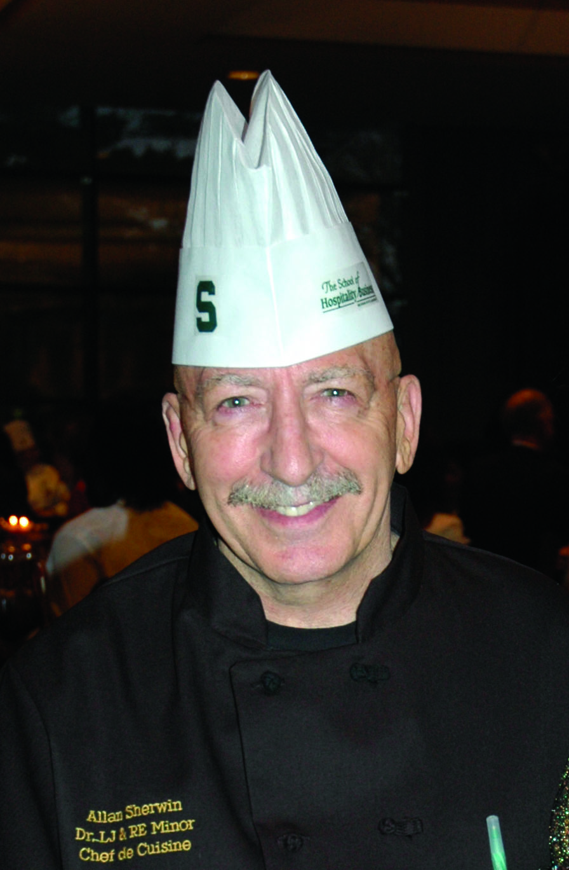
Curriculum Vitae

Of

Allan Sherwin

Home Address: 1142 Hillgate Way, Lansing, Michigan 48912
Business Address: Kellogg Hotel and Conference Center
East Lansing, Michigan 48824-1121
Cell: (517) 899-8752
Office Telephone: (517) 353-5170
E-mail: sherwin@bus.msu.edu
Fax: (517) 355-2190

Education:
Master of Science; Food Hotel and Tourism. Rochester Institute of Technology, Rochester, New York (1991). Bachelor of Arts with High Honor; School of Hotel, Restaurant and Institutional Management, Michigan State University, East Lansing, Michigan.

Industry Experience:
Director of Culinary Services, Sherwin Food Safety, Lutherville, Md. (present) Corporation providing food safety certification, crisis response, HACCP compliance and quality assurance auditing to the food, lodging and travel industry. sherwinfoodsafety.com
Director of Foodservice, Santa Barbara City College, Santa Barbara, Ca. (1999-2001). Responsible for operation of all foodservice on campus. This included cafeteria, catering, gourmet dining room, coffee shop, snack shops and concessions. College enrolled 16,000 students. Volume of sales exceeded $2 million. Responsible for purchasing, maintenance, renovations and future expansion of services.
Director of Foodservice/Culinary Education, Paul Hall Conference Center for Maritime Education and Training. Piney Point, MD. (1994–1999). Responsibilities included menu planning and supervision of staff of 50 for 350-room conference center. Supervised preparation of 1000 meals per day plus one hundred and fifty special events and conferences throughout the year. Responsible for purchase specifications and evaluation of foodservice operations of ships registered in the United States.
President, Alno, Inc., Cleveland, Ohio (1975–1991). Food service company providing catering for private and public sector clients. Banquet and off-premise capabilities for up to 4000.

Sherwin Vita -2-

Chef/Owner, Bliss, Cleveland, Ohio (1980-1984). Specialty restaurant with display kitchens. National Award Winner, Hospitality Magazine (1982).
Director of Catering/Executive Chef, Sherwin’s, Cleveland, Ohio (1970-1975). Multi-unit catering, baking and restaurant management company. Responsible for the catering division, which included on and off-premise events.

Military:
United States Marine Corps (1964-1970). Naval flight Officer. Vietnam (1967-1969). Aide to Commanding General (1968). Flight Instructor (1969-1970).

Teaching Experience:
Dr. Lewis J. and Mrs. Ruth E. Minor Chef/Professor of Culinary Business. The School of Hospitality Business. Michigan State University. East Lansing, Michigan (2004-present). Responsible for teaching courses in food production to students enrolled in The School of Hospitality Business. Additional duties include advising students in planning and production of special events. Consultant to the Culinary Services
Division at Michigan State to provide skills training and curricula for foodservice personnel. Michigan State is the largest self operated food service university in the United States. Approved to teach American Culinary Federation courses in Supervision, Sanitation and Nutrition for academic requirements for certification. Provide seminars to Michigan State University staff on topics for certification for American Culinary Federation designations. Formed a property membership of the American Culinary Federation on Campus.

Program Director Culinary Arts, Hospitality and Business Management. Paul Smith’s College. Paul Smith’s, New York (2002-2004) Responsibilities included oversight of ten instructors in the department and teaching of culinary and management
courses. Assisted in American Culinary Federation accreditation process and served on college assessment and presidential search committees.
Chairman, Department of Culinary Arts/Food Service Management, University of Montana, Missoula, Montana (2001-2002). Responsibilities included curriculum design and assessment, teaching and fiscal oversight and recommendations for future development of new programs. Accredited by American Culinary Federation.
Chairman, Department of Hotel, Restaurant and Culinary, Santa Barbara City College (1999-2001). Responsible for curriculum, selection and evaluation of fifteen faculty, recruitment of students and budget. Accredited by the American Culinary Federation. Active involvement in forming advisory boards composed of hospitality executives in the Santa Barbara area.
Director of Culinary Education (1994-1999). Center for Maritime Studies. Piney Pt., MD. Responsible for directing culinary education programs for United States registered ships, which included deep-water cargo vessels, United States Military Ships, inland cargo ships, United States registered passenger liners and domestic cruise ships. Five hundred students attend the school yearly. Personally taught courses in sanitation certification and contemporary menu planning with emphasis on nutrition, diet and techniques of preparation.

Sherwin Vitae -3-

Director, School of Culinary Arts/Hotel, Restaurant Management. Stratford College (formerly ATI Career Institute). Falls Church, VA. (1992-1994). Responsibilities included curriculum development and evaluation, direction of ten instructors, implementation of programs based on competencies and placement of students. Active involvement in design and construction of new facilities for expanded programs. Initiated culinary program at Quantico Marine Base to deliver competency based skills. First program of its type nationwide. Teaching responsibilities included Advanced International Cooking, Nutrition and Healthy Cooking for ACF Certification, Sanitation for ACF Certification and Sanitation for Certification for the states of Maryland, Virginia, and the District of Columbia.
1993. Invited by the Minister of Education of The Republic of Vietnam to visit and assess hospitality training and make recommendations for implementing competency-based education. Findings presented at a Conference in Ho Chi Minh City in May 1993.

1993. Provided testimony at Congressional hearings in Washington D.C. on competency based education related to the Secretary of Labor’s Commission to Assess Necessary Skills (SCANS).

Visiting Professor, Assistant to Head of Faculty for Research.
Birmingham College of Food, Tourism and Creative Studies. Birmingham, England (1991-1992). Research on Implementation of National Vocational Qualifications in the United Kingdom. Taught courses to postgraduate students on systems applications for hospitality operations. As Visiting Chef/Lecturer, taught Culinary Arts. College operates five restaurants plus central commissary serving one thousand meals per day. Birmingham named College Of The Year in the United Kingdom in 1991 and 1992.

Publications and Scholarly Papers:

Culinary Entrepreneurship: The Business of Culinary. Great River Technology. ISBN: 978-1-61549-174-2

Job Descriptions for Club Occupations. Published by the Club Management Association, Arlington, VA. 450 pp. Fourth edition currently in print.

“Competency Based Education in the United Kingdom.” Paper presented at the 1992 CHRIE Conference in Orlando, Fla.

“Cruise Line Chefs.” Article Published in the National Culinary Review, October 1998.

“Implementation of National Vocational Qualifications in the United Kingdom.” Research findings completed in the United Kingdom, 1992.

“A Study of the Effectiveness of Benefit and Incentive Plans in Decreasing the Rate of Turnover in the Restaurant Industry.” Thesis submitted and published by Rochester Institute of Technology, Rochester, New York, 1991 for fulfillment of the requirements of the degree of Master of Science.

Sherwin Vita -4-

“Delivering Competency Based Training in Culinary Arts in Viet-Nam.” Paper presented at Educational Conference in Ho Chi Minh City, Viet-Nam 1993.

Professional Affiliations:
American Culinary Federation, National Restaurant Association, British Wine Trust, Midland’s of England Chef’s Association, Bread Baker’s Guild, Research Chef’s Association (member of the Education Committee), Society of Wine Educators, Institute of Food Technologists, American Hotel and Lodging Association (member of the Food and Beverage Committee), Michigan State University (member of the University Food Committee and Integrated Dining Committee), Lansing Community College Hospitality Advisory Committee. Advisor to the “Semper Fi Society” (students who at graduation will be commissioned as United State Marine Corps officers), American Mensa Society. Advisor to Culinary Club of Michigan State University.

Professional Designations:
“Chef de Cuisine” from the British Association of Chefs (1992), Certified Executive Chef from the American Culinary Federation (ID#040907, 1993), Food Management Professional (FMP), from the National Restaurant Association (1995), President, Seafarer’s Chapter of the American Culinary Federation (1995-1999), Certified Culinary Educator from the American Culinary Federation (1998), Certified ServSafe Instructor (ID#313644), Wine and Spirit Certification (#84892), London, United Kingdom. Naval Flight Officer United States Marine Corps (#G-1349).

Awards and Honoraries:
Phi Kappa Phi, scholastic honorary; Beta Gamma Sigma, business honorary; Brunswick Foundation Award for Scholastic Excellence; Duncan Hines Foundation Award for Scholastic Achievement; Schlitz Award for Superior Academic Achievement. Military Decorations include; 28 Air Medals, Navy Commendation Medal with combat “V,” Vietnamese Cross of Gallantry and Combat Action Ribbon.

