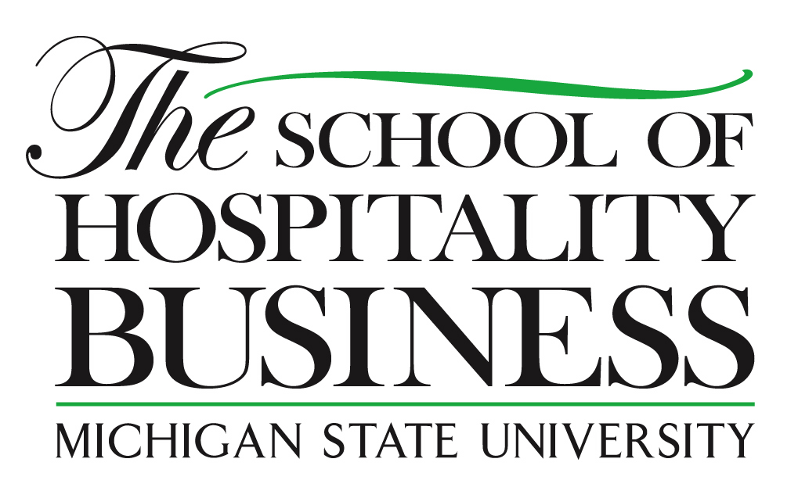



Ray Schmidgall, Ph.D., CPA
Hilton Hotels Professor of Hospitality Financial Management

Ray Schmidgall, Ph.D., CPA is the Hilton Hotels Professor of Hospitality Financial Management and The School’s accounting and financial management expert. He serves on industry committees of the Hospitality Financial and Technology Professionals and American Hotel & Lodging Association. He conducts managerial accounting seminars for CMAA, HFTP and GCSAA. He serves on committees of two academic organizations – International Council of Hotel Restaurant & Institutional Education (I-CHRIE) and the Association of Hospitality Financial Management Educators (AHFME). He is a member of the Board of Directors of Eaglevision, Evangel University, New Life Assembly of God, and The University Club of MSU.

The seventh edition of his Managerial Accounting for the Hospitality Industry was released in 2010. He has authored or co-authored several other books oriented to hospitality accounting and finance. He had eight articles published to add to over 210 articles in the past. His current research includes (1) Financing of Club Renovations, (2) Budgeting Practices in the Club Industry, (3) Job Satisfaction of Hospitality Financial Executives, and (4) Financial Analysis Practices in the Lodging Industry. He also arranges and hosts The School’s annual Hilton Lecture Series.

Prior to teaching, Schmidgall was the financial controller of the Educational Institute, American Hotel & Motel Association and worked as an auditor with Ernst & Ernst. Schmidgall has a bachelor’s degree from Evangel University. Both his MBA and Ph.D. degrees are from Michigan State University. The major focus of his degrees was accounting with minors in statistics, economics, and communications.

